CARB Pollution Mapping Tool

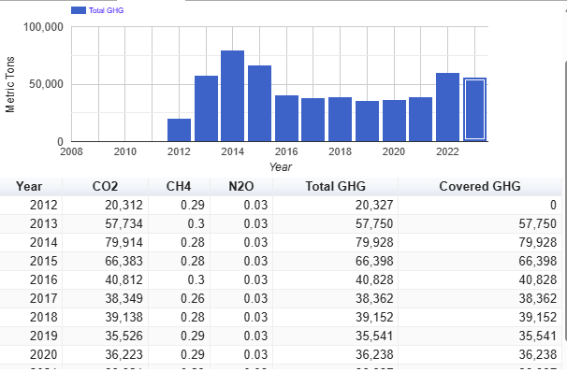

r | VOC | NOx | SOx | PM10 | PM2.5
2012 | 6.5 | 21.6 | 9.7 | 3.6 | 2.4
2013 | 6.2 | 18 | 8 | 3.2 | 2
2014 | 2.5 | 19 | 3.8 | 3.5 | 2.5
2015 | 2 | 23.6 | 6.1 | 3.4 | 2.4
2016 | 2.1 | 20.6 | 5.2 | 2.8 | 1.8
2017 | 2 | 19.4 | 4.3 | 2.6 | 1.7
2018 | 2.4 | 22.3 | 3.3 | 3.6 | 2.4
2019 | 2.4 | 22.8 | 3.6 | 0.8 | 0.6
2020 | 2.3 | 23.1 | 3.6 | 0.8 | 0.7
2021 | 2.5 | 40.9 | 3.9 | 0.8 | 0.7
2022 | 2.3 | 71.5 | 12 | 0.9 | 0.8

ear | CO2 | CH4 | N2O | Total GHG | Covered GHG
2012 | 20,312 | 0.29 | 0.03 | 20,327 | 0
2013 | 57,734 | 0.3 | 0.03 | 57,750 | 57,750
2014 | 79,914 | 0.28 | 0.03 | 79,928 | 79,928
2015 | 66,383 | 0.28 | 0.03 | 66,398 | 66,398
2016 | 40,812 | 0.3 | 0.03 | 40,828 | 40,828
2017 | 38,349 | 0.26 | 0.03 | 38,362 | 38,362
2018 | 39,138 | 0.28 | 0.03 | 39,152 | 39,152
2019 | 35,526 | 0.29 | 0.03 | 35,541 | 35,541
2020 | 36,223 | 0.29 | 0.03 | 36,238 | 36,238
2021 | 38,921 | 0.29 | 0.03 | 38,937 | 38,937
2022 | 59,790 | 0.28 | 0.03 | 59,806 | 59,806
2023 | 55,768 | 0.28 | 0.03 | 55,783 | 55,783

Pollutant | 2012 | 2013 | 2014 | 2015 | 2016 | 2017 | 2018 | 2019 | 2020 | 2021 | 2022 | 2023
1 | Benzene | 21.5 | 246 | 356 | 365 | 329 | 175 | 179 | 121 | 119 | 174 | 141 | 205
2 | 1,3-Butadiene |  | 11.3 | 12.5 | 12.7 | 11.8 | 5.82 | 6.39 | 3.57 | 3.48 | 15 | 10.7 | 16.4
3 | Chromium, Hexavalent | 0.028 | 0.047 | 0.056 | 0.056 | 0.034 | 0.023 | 0.037 | 0.087 | 0.077 | 0.087 | 0.088 | 0.087
4 | Diesel PM |  |  |  |  |  |  |  | 12.4 | 3.04 | 4.28 | 12.67 | 8.93
5 | Formaldehyde | 713 | 1,028 | 1,005 | 1,022 | 635 | 591 | 647 | 638 | 627 | 659 | 684 | 677
6 | Hydrochloric Acid |  |  |  |  |  |  |  | 0.069 | 0.01 | 0.024 | 0.033 | 0.042
7 | Hydrogen Sulfide |  |  |  | 499 |  |  |  | 643 | 632 | 664 | 654 | 647
8 | Nickel | 6.77 | 3.11 | 3.23 | 3.71 | 3.37 | 2.29 | 2.46 | 11.3 | 3.51 | 2.89 | 3.01 | 4.35

